**Cottage Business Registration**

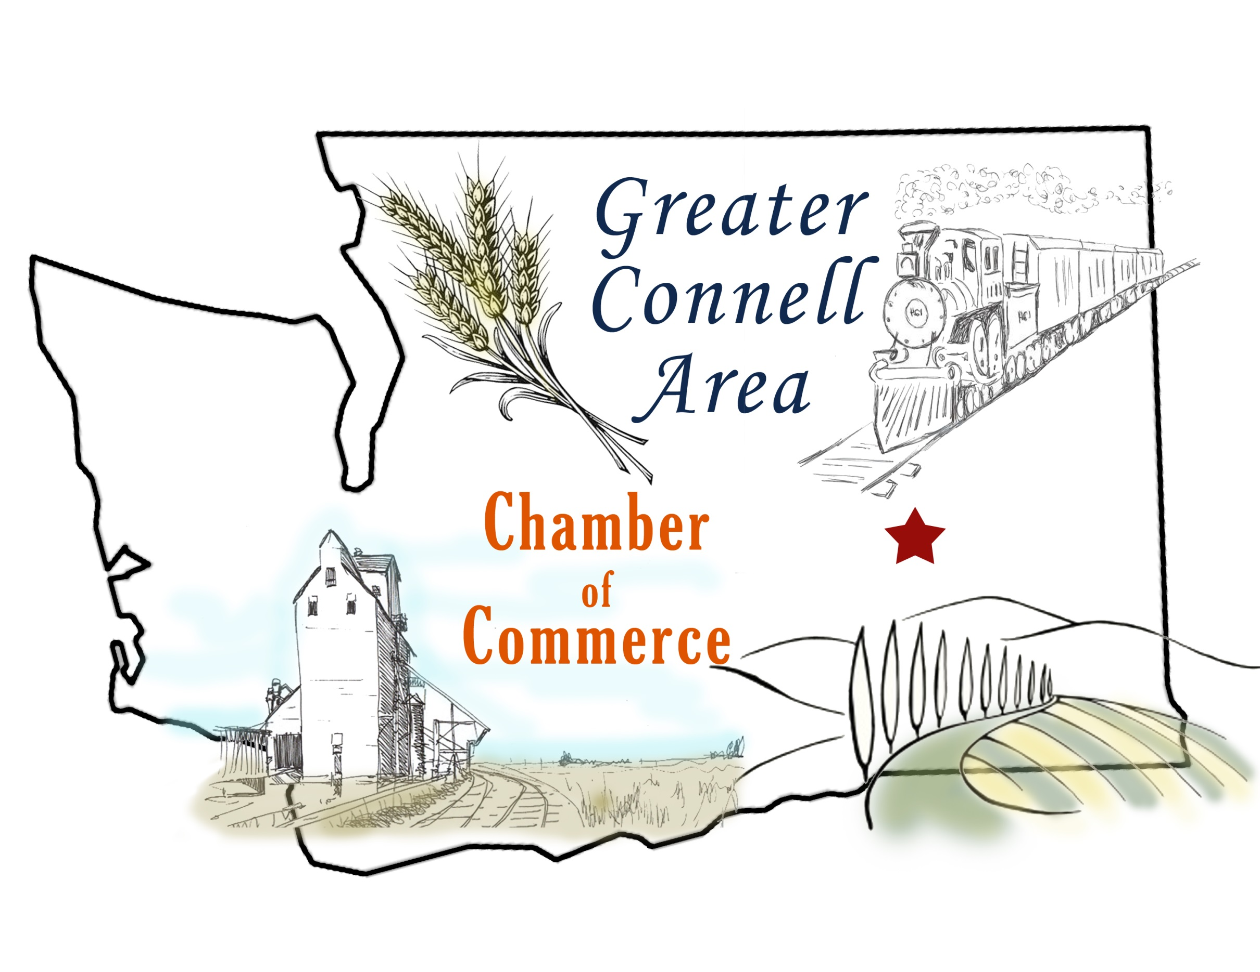

**WINE & BREW 2016**

**November 12**

**6:30p.m. – 10:00p.m.**

We would like to welcome you to **Wine & Brew 2016**. It will be held on November 12 at the Connell Community Center. This event was started to help cottage businesses promote themselves and make contacts within the community; all while doing so in a fun social environment with good food, drink, and music. The table space is free to you. We offer an 8 foot table for you to display your business or we can split that with another business and offer you a 4 foot space. The Chamber will advertise you and the event in the graphic and around town at no cost to you.

Please fill out the form below and send it before October 15th to [connellchamber@gmail.com](mailto:connellchamber@gmail.com) or mail it to: PO Box 401 Connell, 99326.

|  |  |  |  |  |  |  |  |  |  |  |
| --- | --- | --- | --- | --- | --- | --- | --- | --- | --- | --- |
| **Business Name:** Click here to enter text. | | | | | | | | | | |
| **Contact Person:** Click here to enter text. | | | | | | | | **Phone Number:** Click here to enter text. | | | | | |
| **Business Description:** Click here to enter text. | | | | | | | | | | | | | |
| **Mailing Address:** Click here to enter text. | | | | | | | Click here to enter text. | | | | |  | Click here to enter text. |
|  | | | Address | | | | City | | | | |  | Zip |
| **Email Address:** | | | Click here to enter text. | | | | | | | | |
|  | | | | | | | | | | | | | |
| **Table Size Needed:** | 4 foot  8 foot | | **I would like to share the table with:** | | | | | | Click here to enter text. | | | |
| **Do you need table linen?** | YES  NO | | | **Do you need an outlet?** | | | | YES NO | | | | |
| **Time I would like to set up my table:** | | | Click here to enter text. | | | ***Lighting can be an issue. You are welcome to bring a table lamp. Just mark outlet needed.*** | | | | | | | |
| *You may set up your table as early as 3:00p.m. We would like to have all tables set up by 6:00p.m.* | | | | | |
| **If you have other needs, please list and we will try to accommodate you as best we can:**  Click here to enter text. | | | | | | | | | | | | | |

On behalf of the Greater Connell Area Chamber of Commerce we would like to thank you for participating and sharing your business with the community.

Stephanie Melgren

Chamber Manager

509-318-0729